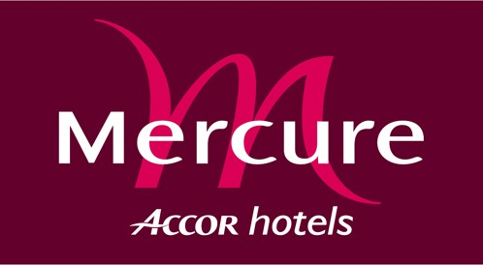

PHRASEOLOGY 2005
Réf :016722
BOOKING FORM

To send by e-mail to : H2200@accor-hotels.com or fax ° 0032 / 10.45.09.11

For the attention of Jaumotte Delphine ( BEFORE: 01-08-2005)

ROOM BOOKING

NAME : FIRSTNAME :

Phone number : Fax number :

Arrival date :
Departure date : Nights :
Room type :

Rates

The rates are per night and breakfast included

- 75 euros for the single room with breakfast
- 86 euros for the double room with breakfast

The payment will be made at departure

GUARANTEE

The room will be kept available till 6 p.m

Late arrivals can be guaranteed by credit card number. Guaranteed reservations can be cancelled without charges until 6 p.m. on the arrival date.
In case of no-show, the first night will be charged.

Credit card company expires in :

VISA
MASTERCARD
AMERICAN EXPRESS
DINER’S CLUB

Signature

